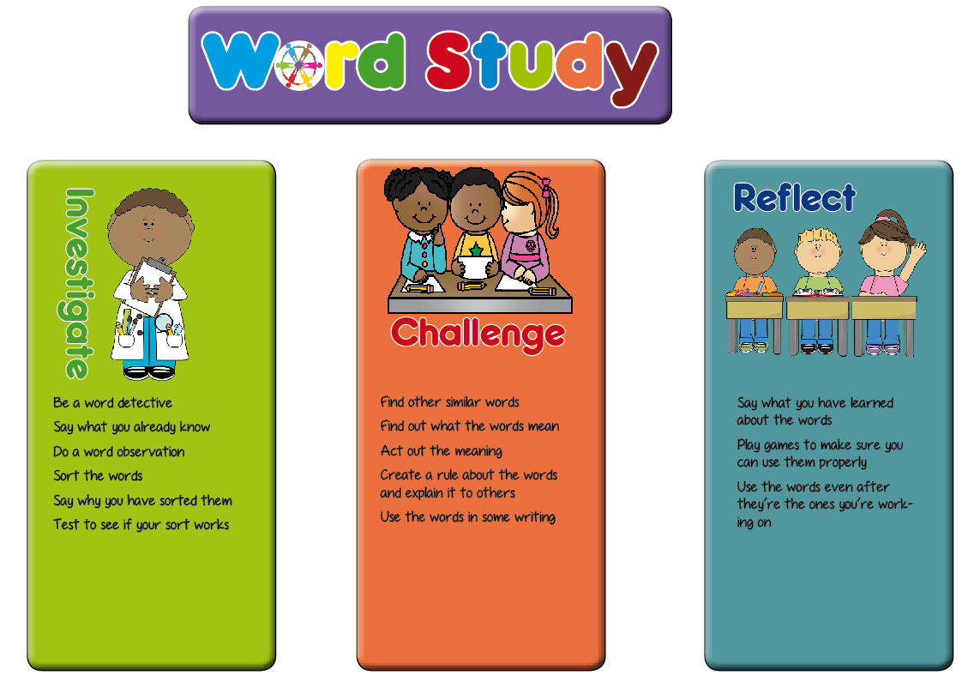**Year 2 Planning Ideas**

In Key Stage One, we have planned a range of generic activities which fit in with the word study teaching sequence. These are a suggestion for ideas which will generate talk for spelling activities and promote enquiry and discussion of the way words work among the pupils.

Hopefully these ideas will be a springboard for the activities you plan in your classroom.

|  |  |  |
| --- | --- | --- |
| **Investigate** | **Challenge** | **Reflect** |
| * Say what they know about the words (modelling) * Soundtalk the words * How many phonemes are there in the word? * Are there long or short vowels in the word? * How many syllables are there in the word? * Look for small words in the whole words * Look at the shape of the words * Look at what the words mean * Do a word sort (see the word sort resources section of the web site) * Say why they have sorted the words in the way they have * Explain what they think the spelling rule sort is | * Explain to someone else how to do the word sort * Finger spy or magnifying glasses to find words that are similar (visit other classes, stuck around the room, in the garden, in their reading books) * Find out what the new words mean (using dictionaries, ask someone at home) * Can you act the words out? * Explain how to use the words * Can you put the words in a sentence? * Can you find other words with the same pattern to add to your word sort? | * Play hangman with the words * Play bingo with words * Play snap with words * Build with magnetic letters (could be timed) * In pairs, take turns to spell the words * Spelling investigation writing – use different colours * Have a poster area for children to add words to the word sort as they find them in their reading |

**This list of tasks for spelling is taken from the planning structure at Shakespeare and More** [**www.shakespeareandmore.com/spelling.html**](http://www.shakespeareandmore.com/spelling.html)

|  |  |  |
| --- | --- | --- |
| **Autumn Term Year 2 list** | **Teaching Guidance** | **Word List** |
| **The /d_ʒ/ sound spelt as ge and dge at the end of words, and sometimes spelt as g elsewhere in words before e, i and y** | The letter j is never used for the /dʒ/ sound at the end of English words.  At the end of a word, the /dʒ/ sound is spelt –**dge** straight after the /æ/, /ɛ/, /ɪ/, /ɒ/, /ʌ/ and /ʊ/ sounds (sometimes called ‘short’ vowels).  After all other sounds, whether vowels or consonants, the /dʒ/ sound is spelt as –**ge** at the end of a word.  In other positions in words, the /dʒ/ sound is often (but not always) spelt as g before e, i, and y. The /dʒ/ sound is always spelt as j before a, o and u. | badge, edge, bridge, dodge, fudge  age, huge, change, charge, bulge, village  gem, giant,  magic, giraffe, energy  jacket, jar, jog, join, adjust  *(Shakespeare and More List 7)* |
| **The /s/ sound spelt c before e, i and y** |  | race, ice, cell, city, fancy  *(Shakespeare and More List 7)* |
| **The /n/ sound spelt kn and (less often) gn at the beginning of words** | The ‘k’ and ‘g’ at the beginning of these words was sounded hundreds of years ago. | knock, know, knee, gnat, gnaw  *(Shakespeare and More List 7)* |
| **The /a_ɪ/ sound spelt –y at the end of words** | This is by far the most common spelling for this sound at the end of words. | cry, fly, dry, try, reply, July  *(Shakespeare and More List 8)* |
| **Adding –ed, –ing, –er and –est to a root word ending in –y with a consonant before it.**  **Adding –ed, –ing, –er and –est to a root word ending in –e with a consonant before it.**  **Adding –ing, –ed, –er, –est and –y to words of one syllable ending in a single consonant letter after a single vowel letter** | The **y** is changed to **i** before **–ed**, **–er** and **–est** are added, but not before **– ing** as this would result in **ii**. The only ordinary words with **ii** are *skiing* and *taxiing*.  The last consonant letter of the root word is doubled to keep the /æ/, /ɛ/, /ɪ/, /ɒ/ and /ʌ/ sound (i.e. to keep the vowel ‘short’).  **Exception**: The letter ‘x’ is never doubled: *mixing*, *mixed*, *boxer*, *sixes*. | copied, copier, happier, happiest, cried, replied  hiking, hiked, hiker, nicer, nicest, shiny  patting, patted, humming, hummed, dropping, dropped, sadder, saddest, bigger, biggest, runner, runny    *(Shakespeare and More List 8)* |
| **Common exception words** | door, floor, poor, because, find, kind, mind, behind, child, children, wild, climb, most, only, both, old, cold, gold, hold, told, every | |